stack performance

1.space O(n)

2.each operation runs in time O(1)

Postfix Notation

Advantages of postfix notation

1.No need to use parentheses

2.No need to consider precedence(不用考慮優先順序)

Two rules of conversion (infix to postfix)

1.once a right parenthesis is placed things between parentheses are poped out.

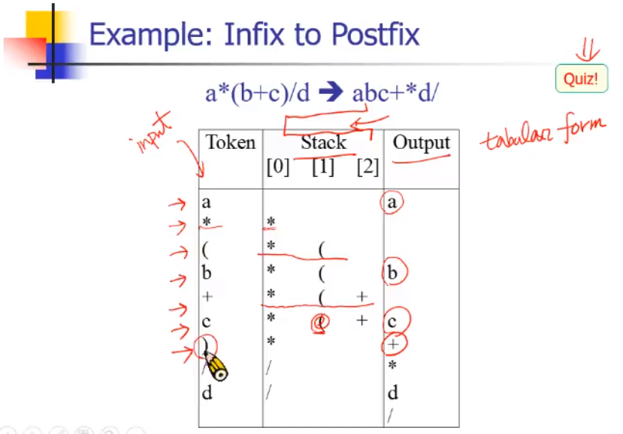

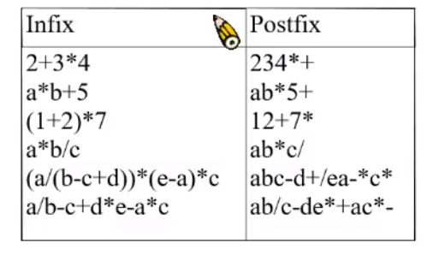

Breadth-first search (Queue)

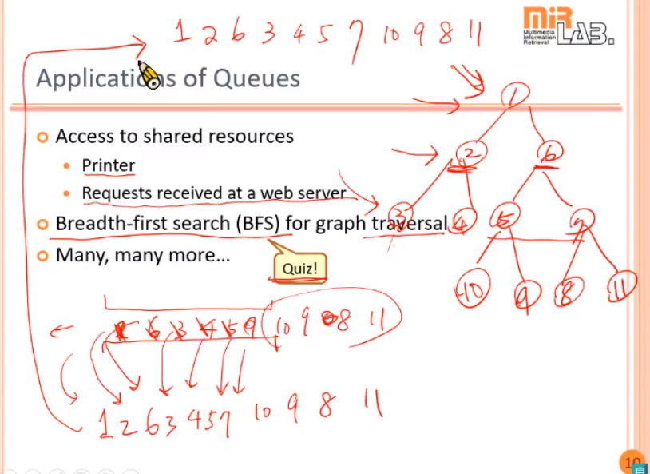

BFS and DFS:

BFS: need more memory

DFS: more preferred

在同一條分支上先pop長出分支。